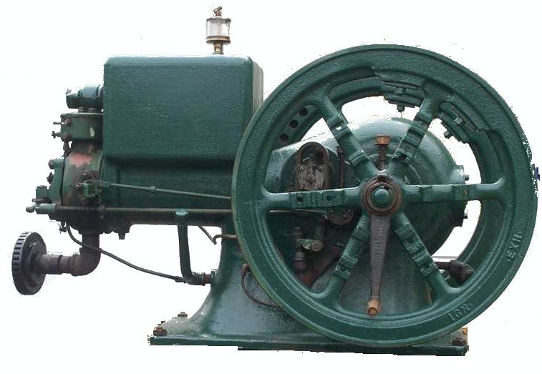
F O O T H I L L S

F O O T H I L L S

ANTIQUE POWER ASSOCIATION
ESTABLISHED 2003

September 2015
Dear Members,
The calendar has passed to September – the time (along with October) when every week has something going on. It can be almost dizzying to keep it all straight, much less to participate in much of it. Of course, none of us could do it all. But we encourage as many of you as possible to attend as much as you can. A few special events are detailed below so you will have as much information as possible so you can plan appropriately.

--- --- --- From the September Meeting --- --- ---

- The need for prayer is continuous. God is always present. He knows our situations and needs. Are we willing to set aside our selfish nature and take a few minutes to speak with Him, not for ourselves, but on behalf of someone else?

  - Kelly Blanton
  - Glenn & Dot Hawn
  - Butch Minyard
  - Nancy Edgar
  - Gerry Stewart
  - Sheldon Smith
  - Rev. Bobby Langston
  - Allen Everdyke
  - Lorna Sheets
  - Charles Huffman
  - Steve Hefner
  - Penny Hodges
  - Justin Beach
  - Wade Hefner
  - Charles Elmore
  - Norris Turner
  - Don Johnson
  - Stewart (Ranny) Frye
  - Ned Story
  - Carl Porter
  - Jane Abernathy
  - Terry Martin
  - Jim Davis
  - Eugene Hartley
  - Charles McRee
  - Ann Cline
  - Hoyle Hoover
  - Carroll Hilliard

- The Swap Meet is coming up Saturday Sept 19. Gather up all the stuff you’d like to sell, and tally up your list of things you’d like to buy.
  - Gates open at 6AM for sellers and 7AM for the public. Admission is $5 (under 12, free). Food and drink will be available.

- The Raffle Dinner is also scheduled for that same Saturday evening.
  - As last year it will be held at Bethel Lutheran Church Fellowship Hall off Riverbend Rd north of Claremont.
    - To get there from the Newton and Hickory areas, take NC 16 north. Turn left onto Oxford Sch. Rd, travel about 2 miles and turn left onto Riverbend Rd. Bethel will be on your right after about ½ mile.
    - From the Taylorsville area, travel NC 16 across the river, then turn left onto Oxford Sch Rd. Travel about 2 miles and turn left onto Riverbend Rd. Bethel will be on your right after about ½ mile.
    - From the Catawba & Claremont areas, travel Oxford Sch Rd north, turn right onto Riverbend Rd. Bethel will be on your right after about ½ mile.
  - The dinner will be catered by BoxCar Grille. The menu will feature sirloin tips or baked chicken. Dinner will be served at 6PM, then, after dinner, the raffle will begin at around 7:30PM.
  - We also would like to ask our ladies if they would bless us all by bringing a dessert to finish off the meal.
  - There are only a few raffle tickets left. See Ned Story to purchase one.
    - Each $50 ticket gives the purchaser one chance in the drawing. It also entitles the bearer to two dinners.
  - The raffle works best if all tickets are purchased. When the drawing starts, the holder of the first ticket drawn will receive $50, the 50th and 100th ticket-holders will each receive $100, the 150th will receive $150, etc. for 200 and 250, that is, if enough tickets are sold. Then the final ticket drawn will receive the $3000 grand prize.

- Our club outing is coming up on Saturday, October 3.
  - Once again, Glenn Sigmon has graciously offered to provide us the privilege of gathering at his place on the river.
  - We would like everyone to arrive by 5:00 PM for the annual club photo and presentation of show proceeds to our charities, but all are encouraged to come early as you can to enjoy a time of fellowship and enjoy the peacefulness of Glenn’s place. The evening dinner will begin around 6PM, but come early so we can enjoy some more fellowship together.
  - If you’ve never been there before, it is easy to find.
    - From NC16 about 2 miles south of Oxford Dam, turn east onto River Bend Road.
    - Travel about 2 miles, then turn left (north) onto Hafer Rd. and go to the end of the road.
  - Glenn is such a wonderfully gracious host and we truly appreciate his willingness to share his home with all of us.

- The upcoming October meeting will be the time for election of officers and board members.

--- --- --- UP-COMING EVENTS --- --- ---

Sept 19 Newton FAPA Swapmeet
Sept 19 Claremont Raffle dinner
Sept 25-26 Yadkinville Glory Days Antique Power Phow
Sept 26-27 Catawba Murray’s Mill Fall Festival
Oct 1 Sig’s October monthly meeting
Oct 2-3 Morganton Valley Hills show
Oct 3 Catfish FAPA fall outing at Glenn Sigmon’s
Oct 9-11 Dallas Cotton Ginning Days
Oct 16-18 Charlotte Stumptown Tractor Show
Oct 22-24 Arden WNC Fall Harvest Days
Nov 5 Sig’s November meeting
Nov 6-8 Carthage Train & Tractor Show
Nov 7 Hickory Mt Grove Baptist Ch HarvestFest

--- --- --- THE CLASSIFIEDS --- --- ---

Is there anything you would like to sell or are you looking for something special? List it here.
(Item listings will run for 3 months before expiring. Let us know when an item is sold or bought.)

FOR SALE

1951 Super A, GC, runs VG, 80% rubber, +cultivators, Alice Parris, 704-462-2010 (15-05).

1939 John Deere B + cultivators & blade, Ruthie Conner, ruthieconner@gmail.com (15-08).

1941 John Deere A, Ruthie Conner, ruthieconner@gmail.com (15-08).

John Deere A & B for parts, Ruthie Conner, ruthieconner@gmail.com (15-08).

Massey-Harris Pony, Michael Rector, mikerector@aol.com 828-612-6309 (15-08).

2 Farmall Cubs, Michael Rector, mikerector@aol.com 828-612-6309 (15-08).

Woods belly mower, cultivators, plow, disc, sickle mowers, Michael Rector, mikerector@aol.com 828-612-6309 (15-08).

WANTED

John Deere B, Randy Rhodes, 828-394-2844, Jdeeretractor@hotmail.com (15-08).

☺ ☺ !!!!! HAPPY BIRTHDAY !!!!! ☺ ☺
September birthdays

1 – Dylan Cabe
3 – James West
6 – Danny Miller
7 – Leon Baker
8 – Mike Grishaber
9 – Kelly Nash
12 – Danny Scarbro
12 – Gwynn Yount
13 – Patrick Hepburn
13 – Mark O. Sigmon
15 – Rachel Keller
16 – Tim Miller
18 – Kennerth Beach
22 – Bruce Long
23 – Clay Cannon
25 – Dawhite Moody
29 – Glen Minyard

October birthdays

1 – Doug Carrigan
1 – Brian McIntosh
5 – Tim Hollar
5 – Richard Hudson
7 – David Setzer
8 – Bob Huffman
13 – Jeff Bowman
17 – Todd Painter
18 – Johnny Parsons
19 – Eugene Lefeber
19 – Tyler Lutz
28 – Keith Beck
28 – Richard Drum
28 – Glenn Hawn
28 – Jim Leatherman

5851 St. Peter’s Ch. Rd. Conover, NC 28613
President: Kevin Black 828-464-1950 Vice Pres: Wilson Sigmon 828-256-2176
Treasurer: Kermit Nash 828-459-9616 Secretary: David Setzer 828-850-4943
Show Chair: Ned Story 828-464-6399 Asst.Show Chair: Teddy Hefner 828-310-5525
Asst. Secretary: Kevin Sigmon 828-256-2176
www.foothillsantique.com
--- --- --- something to think about --- --- ---

Remember the record of Mary and Martha when Jesus came to visit? (Luke 10:38-42). Mary sat at his feet – that is, she was attentive to what he had to say. Martha, on the other hand, was distracted from that by all the work she had to do to get the meal ready. She even asked Jesus to encourage Mary to come help her. “Martha,” he said, “you are overly anxious about too many things, but only one thing is needful right now – one dish is ready to serve and Mary has already started to eat.”
There are times when things need to be done. For each of us they will be different, yet we all have one thing in common – we find ourselves overly concerned with them and we get anxious and worried about them. Before long we find ourselves so overwhelmed by that anxiety that even the necessary things don’t get done well.
Martha was in this situation – deeply concerned about doing what she thought had to be done and so overwhelmed by that concern that she could not enjoy the moment. (“How am I to get all of this done without help and the help I need is sitting there doing nothing?”) Jesus did not tell her that what she was doing was unimportant, but that another thing was more needful at the moment. We do not know what happened after that, but we can probably rest assured that, when it was time to eat, the meal was enjoyed by all.
Jesus may not be physically in our living room, but the same meal is ready to be eaten. (“Man shall not live by bread alone …”) If we are so busy trying to take care of everything else, we’ll miss out. “Seek first the kingdom of God and all these things (the necessities of life) will be provided when they are needed.” There is, then, no need to worry about what has not yet happened. There will be enough worry to go around tomorrow without adding it to today’s (Matt. 10:33-34).
How can we not be anxious and worrisome when it seems we are always faced with troubles and problems? The simple answer is: trust God?
How do we trust God? First, we must learn of Him, not just that He is, but learn to know what He has promised (by reading and studying His Word) and learning that He is trustworthy and faithful to keep His Word. Trust/faith is not passive. It is active. We must go to Him in acknowledgement that we can’t, but He can (Philippians 4:6-7). When we rely on Him instead of ourselves, He will give peace to our hearts and minds so we will not be anxious about the problems we face. He cares for us (1 Peter 5:7), all we need to do is trust Him to do it.
There is always work to be done, there will always be problems to face, but, if we put first things first, we can go to it, no matter what it is, knowing that we have help.

God bless you.
See you in October.
Your Secretary,
David Setzer

